Hello Minikube:
Use the kubectl create command to create a Deployment that manages a Pod. The Pod runs a Container based on the provided Docker image.
View the Deployment:
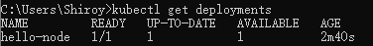
View the Pod:
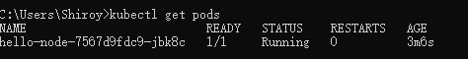
View cluster events:
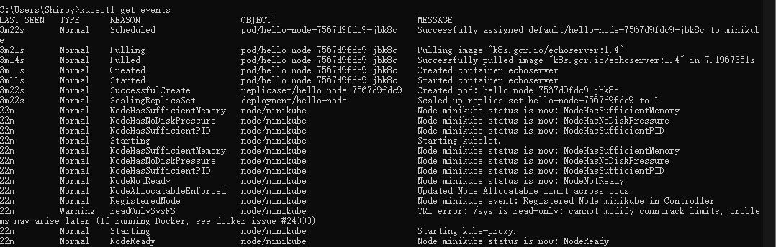View the kubectl configuration: 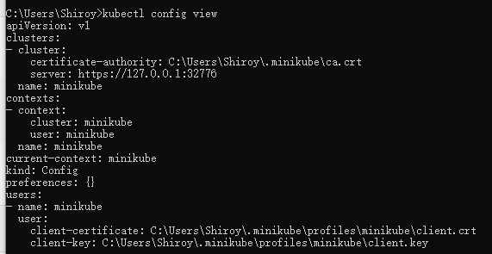

Create a Service
Expose the Pod to the public internet using the kubectl expose command:
View the Service you just created:
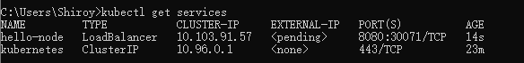
Run the following command:
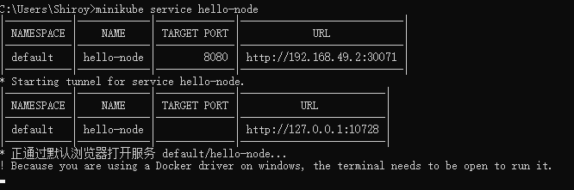

Enable addons
List the currently supported addons:
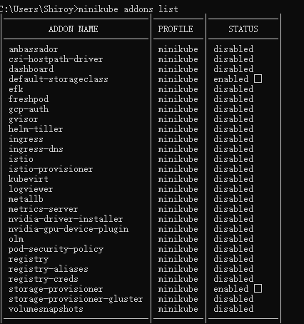
Enable an addon, for example, metrics-server:
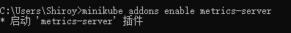
View the Pod and Service you just created:
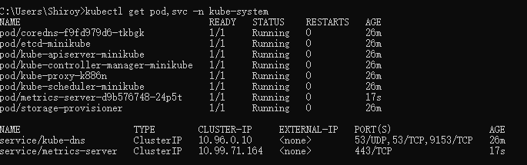
Disable metrics-server:
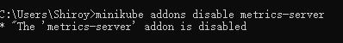

Clean up
Now you can clean up the resources you created in your cluster:
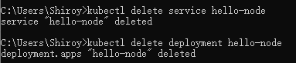
Optionally, stop the Minikube virtual machine (VM):
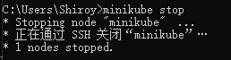
Optionally, delete the Minikube VM:
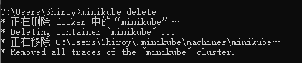

Interact with cluster
From a terminal with administrator access (but not logged in as root), run:
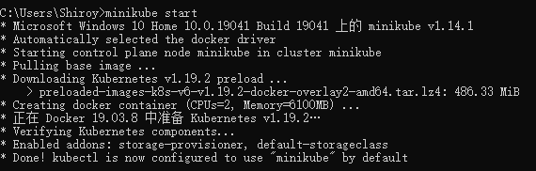
If you already have kubectl installed, you can now use it to access your shiny new cluster: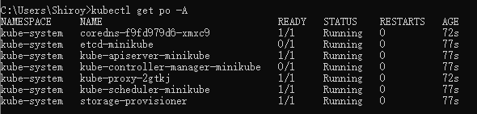
Alternatively, minikube can download the appropriate version of kubectl, if you don’t mind the double-dashes in the command-line: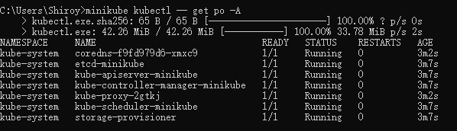
Initially, some services such as the storage-provisioner, may not yet be in a Running state. This is a normal condition during cluster bring-up, and will resolve itself momentarily. For additional insight into your cluster state, minikube bundles the Kubernetes Dashboard, allowing you to get easily acclimated to your new environment: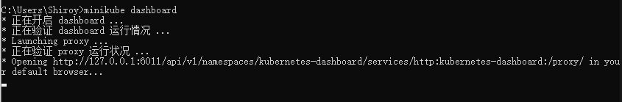

Deploy applications
Create a sample deployment and expose it on port 8080:
It may take a moment, but your deployment will soon show up when you run:
The easiest way to access this service is to let minikube launch a web browser for you: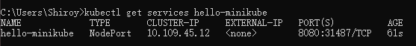
Alternatively, use kubectl to forward the port: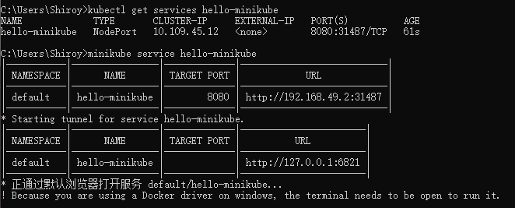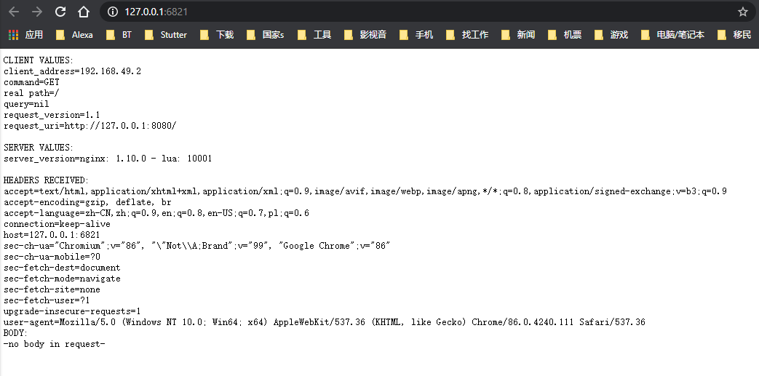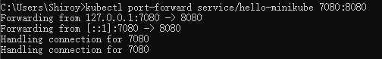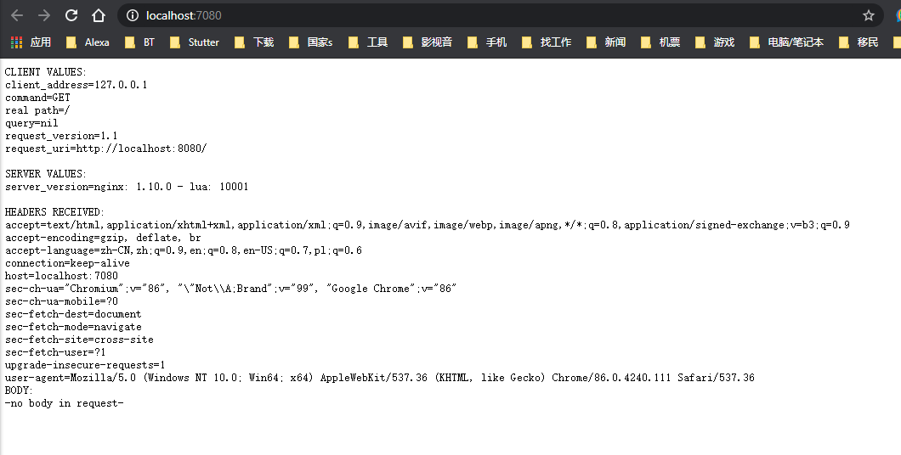

LoadBalancer deployments
To access a LoadBalancer deployment, use the “minikube tunnel” command. Here is an example deployment:
In another window, start the tunnel to create a routable IP for the ‘balanced’ deployment:

To find the routable IP, run this command and examine the EXTERNAL-IP column:
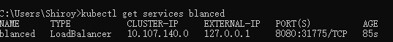

Manage cluster
Pause Kubernetes without impacting deployed applications:
Halt the cluster:
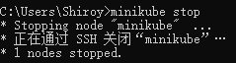
Increase the default memory limit (requires a restart): Browse the catalog of easily installed Kubernetes services:
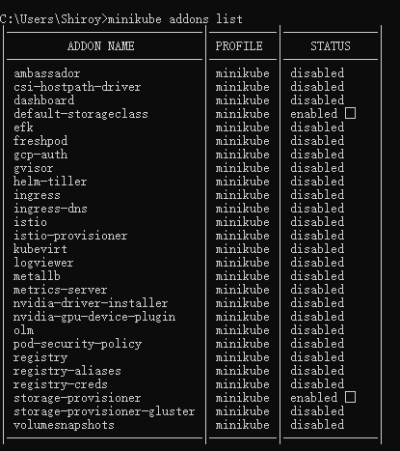
Create a second cluster running an older Kubernetes release:
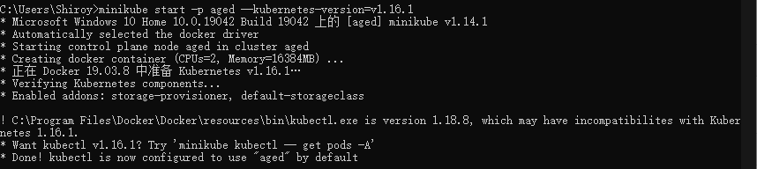Delete all of the minikube clusters: 